**Leader Overview**

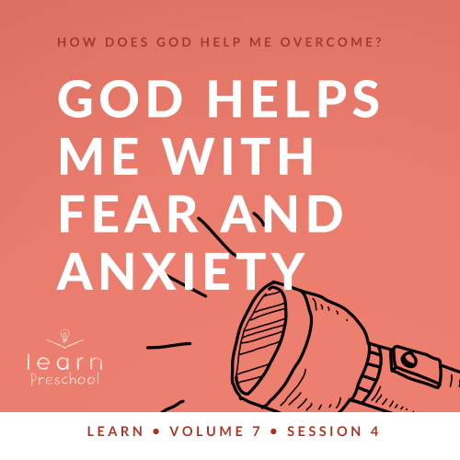

**Volume Overview**

**How does God help me overcome?**

*Life can be full of challenges. Thankfully, when we make the decision to live for God, we can have confidence that we’re no longer walking through life alone. God offers His help to us throughout every difficult circumstance. He knows that we’ll face fears, decisions, and emotions that we don’t feel equipped to handle. When we don’t know what to do, we can turn to God for the answer. He will help us overcome every challenge.*

**Session Overview**

**God Helps Me with Fear and Anxiety**

*In this* **Learn** *session, preschoolers will discover that we can trust God with our fears. As believers, we can respond with faith and know that God will help us. Through the story of Jacob moving to Egypt, kids will learn that God can help us to overcome fear.*

**Bible Lesson**

Jacob Overcomes Fear

[Genesis 42:1–4](https://ref.ly/logosref/Bible.Ge42.1-4); [45:16–18](https://ref.ly/logosref/Bible.Ge45.16-18); [46:1–5](https://ref.ly/logosref/Bible.Ge46.1-5)

**Faith Fact**

God helps me when I am afraid.

**Faith Verse**

[Philippians 4:13](https://ref.ly/logosref/Bible.Php4.13) (NLT)

For I can do everything through Christ, who gives me strength.

**Preparing for the Session**

**Leader Preparation Time: 20–25 Minutes**

|  |
| --- |
| ***You Will Need***  ***Preservice Activities***   * *Stickers, one per kid* * *Travel food (small sandwiches, cheese cubes, pretzels, juice boxes, etc.)* * *Toys*   ***Large Group***   * *Bible* * *Worship songs (Song suggestions: “What a Mighty God We Serve” by Listener Kids; “God Is Big and He Loves Me” by Yancy; “God Makes Me Brave” by LifeKids)* * *For groups not using a phone or tablet only, add:*   *• Projector or TV*  *• Laptop*  *•* ***Faith Fact Sound*** *video (bell ringing)*  *•* ***Faith Fact Slide***  ***• Faith Verse Slide***  ***• Bible Lesson Video A***  ***• Bible Lesson Video B***  ***Small Group***   * ***Small Group Group Connection Page*** * *Scissors* * ***Small Group Activity Page****, one per kid* * ***Small Group Activity Page Answer Page*** * *Crayons, markers, or colored pencils* * *Six plastic cups for stacking* * *Soft or bouncy ball* * *Floor-safe tape* * *Optional: Fear pictures from the Group Connection activity* * *Wax paper* * *Permanent marker* * *Washable markers* * *Bowl or pan* * *Water* * *Paper towels, one per group*   *To access session content and videos from a computer, visit:* [*BibleEngagementProject.com/downloads*](https://bibleengagementproject.com/downloads) |
| ***Getting Ready***  ***Preservice Activities***   * *Set out toys and snacks.*   ***Large Group***   * *Download videos and slides if needed.* * *Select worship song(s) and have them ready to play.*   ***Small Group***   * *Print and cut apart the* ***Small Group Group Connection Page****, one per group.* * *Print copies of the* ***Small Group Activity Page****, one per kid.* * *Print a copy of the* ***Small Group Activity Page Answer Page****.* * *Tape one line on the floor for kids to stand behind.* * *Stack the cups about ten feet from the line.* * *Optional: Tape a Fear picture to each cup.* * *On a piece of wax paper, write the word “God” with a permanent marker, one per group.* * *Fill the bowl or pan with water.*   *First time leading* Learn *for Preschool? Check out the* [*Facilitator Guide*](https://0b769b0ed3569ef9d18b-f88d8272f61086866d50d048b43ef630.ssl.cf2.rackcdn.com/sites/biblengagementproject/Listen_Facilitator_Guide.pdf)*.* |

**Preservice Activities**

*See what’s needed at the beginning of the session.*

**Bible Story Warm-Up**

*(Hold up a sticker.)* Does anyone here like stickers? *(Group response)* Have you ever been to a doctor or dentist and they gave you a sticker when you left? *(Group response)* Why do you think they give stickers to kids? *(Allow responses.)* Sometimes kids get nervous or a little scared when they go to the doctor or dentist.

When do you feel scared?

What do you do when you feel scared?

Who or what helps you to feel better when you’re scared?

There are some very real things that we can be afraid of. I’m glad that you have people in your life who help you feel less scared. In our Bible story today, we’ll learn about a man who was scared about something bad happening to him and his family. He discovered that God was with him the entire time. We’ll find out how God is with us.

**Snack**

**Travel Food (Small sandwiches, cheese cubes, pretzels, juice boxes, etc.)**

*As kids are eating the snack, share the following:*

In today’s Bible story, Jacob and his family need to move to a new home. It was a long way from where they lived, so they needed to pack food to eat on the trip.

What is your favorite snack to eat when you’re traveling in a car?

Do you enjoy taking long trips?

Have you ever had to move to a new house?

What was the scariest part about moving?

It can be scary to go to new places. That’s why we’re going to talk about how God can help us when we’re afraid. I can’t wait to learn more about that with you.

**Free Play**

*Any extra time can be spent playing with toys.*

**Transition**

*A few minutes before service begins have kids make their way to the large group area and sit in their designated areas.*

**Large Group**

**25 Minutes**

*See what’s needed at the beginning of the session.*

**Introduction**

Hey, kids! I’m glad you’re here today. The Bible is kind of like a road map that God has given us. The more we read it, the more we know how to live. If you’re excited to learn with me today, say, “Hooray!” *(Group response)*

Today, we’ll learn that we can trust God with everything. We can trust Him with our good days and our bad days. We can trust God with how we feel. Did you know that God loves to hear from you about your day? *(Group response)* We can trust God with our best moments and our worst. We can even trust God with our fears. God is so much greater than anything we could be afraid of, and He wants to help us.

**Faith Fact**

That reminds me of today’s Faith Fact. It says God wants to help us. Our Faith Fact today is **God helps me when I am afraid.**

• *Show the* ***Faith Fact Slide.***



Since we’re talking about fear, we’d better say our Faith Fact as loud as we can. Let’s show our fear that we’re not scared anymore. Ready? **God helps me when I am afraid.** Now, let’s put our hands up high and stomp our feet as we say it. Ready? **God helps me when I am afraid.** Great job!

**Bible Time**

Out of all the things we could do together, one of the most important things is to learn from God’s Word, the Bible. *(Hold up the Bible.)* Not only is it really important, but it’s also fun. The Bible is an amazing book of stories, adventures, and promises, all pointing to one thing: God. Today, we have someone special to help us learn. Let’s see what Lizzy is doing.

• *Play* ***Bible Lesson Video A.***

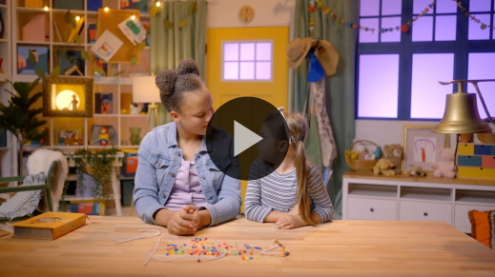

Wow! You did great helping Lizzy solve those clues. In our Bible story, why was Jacob so scared? *(Allow responses.)* He was afraid that something might happen to Benjamin. Also, Jacob was afraid to move to a new place. Have you ever had to move to a new place? *(Group response)* It can be scary to move.

Even though Jacob was scared, God was with him the entire time. God took care of Jacob and all of his family. Like Jacob, we can trust God to help us when we are afraid. That reminds me of our Faith Fact. Say it with me. **God helps me when I am afraid.**

**Worship**

When we trust God to take care of us, we show Him that we love Him. Another way we can show God that we love Him is to worship Him together.

**Praise**

Are you glad God takes care of you? Wave your hands up high. *(Group response)*

Are you glad God helps you when you’re scared? Give yourself a tight hug. *(Group response)*

Are you ready to worship Him? Stomp your feet. *(Group response)*

**Sing**

I think we’re ready to worship God by singing now.

• *Lead the kids in singing one or two songs. See song suggestions at the beginning of the session.*

**Prayer**

It’s such a special time when we focus on God and worship Him. I know God loves listening to you sing. Now, let’s take a moment and talk to God.

|  |
| --- |
| Dear God, we love You so much. Thank You for always being with us. Thank You for caring about how we feel. Please help us when we feel afraid. Amen. |

**Bible Time cont’d**

The more I talk to God, the more I want to know about Him. One way we can learn more about God is by studying the Bible. Learning Bible verses is a great way to do that. Let’s check back in with Lizzy to practice our Faith Verse.

• *Play* ***Bible Lesson Video B.***

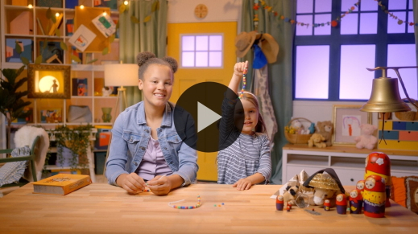

Amazing! You’re doing an incredible job of learning our Faith Verse. This verse reminds us that Jesus is with us. It’s one more way God is telling us that He will take care of us.

**Response Time**

• *Play a worship song quietly.*

Like Jacob in our Bible story, sometimes even grown-ups get scared, but God is always with us. We can trust that God will help us when we’re afraid. Let’s take a few moments and respond to what we’ve learned today. Let’s ask God to help us be brave and to remember that He will help us when we are afraid.

• *Optional: Have the kids repeat phrases of the prayer after you.*

|  |
| --- |
| Dear God, thank You for Your promise that You will help me when I’m afraid. Sometimes I get scared, but I want to remember that You are stronger than anything. Help me to trust You with my fears so that I can overcome them. Amen. |

**Faith Verse**

Did you know God loves it when we learn Bible verses from His Word? Let’s say our Faith Verse and do the actions together.

[Philippians 4:13](https://ref.ly/logosref/Bible.Php4.13) (NLT)

For I can do everything through Christ, who gives me strength.

• *Show the* ***Faith Verse Slide.***

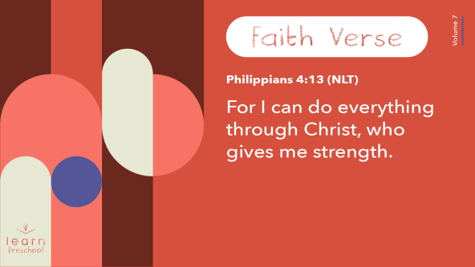

That was great! You’re doing an amazing job of learning our Faith Verse.

**Closing**

Who had fun learning about God today? *(Group response)* It’s been so great getting to learn, worship, and have so much fun together. Today, we learned that no matter what happens, God is bigger than the fear we might face. When we’re scared, we can trust God with our fear and know that He will help us.

• *Play the* ***Faith Fact Sound*** *video (bell ringing).*

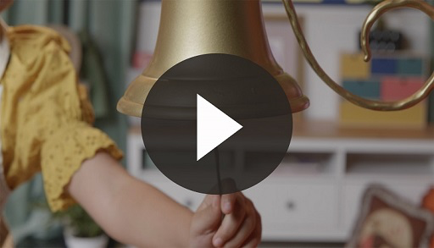

Wow! That was perfect timing. Let’s say our Faith Fact one more time together! **God helps me when I am afraid.**

• *Show the* ***Faith Fact Slide.***



Let’s say it in slow motion. **God helps me when I am afraid.** Now, let’s say it one more time as fast as we can. **God helps me when I am afraid.**

**Dismissal to Small Groups**

Fantastic! Let’s keep the fun going as we head to our small groups.

• *Dismiss the kids by groups.*

|  |
| --- |
| ***Leader Tip****: This can be done by assigning color teams or by age groups. Note that some young preschoolers may not know their age. Using a colored sticker, jersey, or wristband will help separate the kids and help identify their small groups.* |

**Small Group**

**25 Minutes**

*See supplies and prep instructions at beginning of session or in each activity below.*

|  |
| --- |
| ***Leader Tip****: Small groups can alternate to each circle, or all groups can do each activity at the same time. If you choose to alternate, you will need at least one leader per circle.* |

**Circle 1**

**Group Connection**

**Bigger Than**

|  |
| --- |
| ***You Will Need***   * ***Small Group Group Connection Page*** * *Scissors*   ***Getting Ready***   * *Print and cut apart the* ***Small Group Group Connection Page****, one per group.* |

Have you ever been afraid of something? *(Group response)* Raise your hand if you’ve ever been afraid of any of the things that I show you. Maybe you used to be afraid of it, but you’re not anymore.

• *Show kids the pictures one at a time and let them respond. Place all the pictures in front of the kids.*

Now, I want you to think about which one of these is the scariest of all. Then, sit by that picture. I’ll go first.

• *Share which thing you are/were afraid of and sit by it. Then, let each of the kids respond.*

Everyone put your thumb out in front of you as far as you can. Now, move your thumb so the thing you fear most is behind it. Your thumb looks pretty small compared to the picture, doesn’t it? *(Group response)*

Now, I want you to close one eye. You can hold it shut with your other hand if you need to. Keep looking at the picture of the scary thing. Then, turn your thumb sideways and slowly bring it closer to your open eye. What happens to the scary thing as you do that? *(Allow responses.)*

The closer your thumb gets to your eye, the bigger your thumb is. What happens to the scary thing? It looks smaller. In fact, the scary thing eventually gets covered up, and you can’t even see it.

• *Pause to make sure all of the kids understood the instructions and get their scary picture to “disappear.”*

When we focus on God instead of our fears, our fears get smaller. Our God is way bigger than anything we’re afraid of. The more we look closely at God, the less we’ll see our fears. Eventually with God’s help, they’ll go away. Turning our attention toward God is one way that He helps us when we’re afraid.

God also provides people who can help us. It’s never a good idea to keep our fears a secret. We should always tell someone who loves us what we’re afraid of. God can use them to help us.

• *Optional: Save the pictures for the Feet-to-Floor Game Time.*

**Circle 2**

**Activity Page Time**

**Amazing God, Little Fear**

|  |
| --- |
| ***You Will Need***   * ***Small Group Activity Page****, one per kid* * ***Small Group Activity Page Answer Page*** * *Crayons, markers, or colored pencils*   ***Getting Ready***   * *Print copies of the* ***Small Group Activity Page****, one per kid.* * *Print the* ***Small Group Activity Page Answer Page****.* |

God wants to help us when we’re afraid. In our Bible story, we learned how God helped Jacob when he didn’t want to move to Egypt. Today, we get to help Jacob overcome his fear.

• *Hand out a copy of the* ***Small Group Activity Page*** *to each kid.*

Jacob is far away from Egypt in our picture. Can you help him make his way through this maze of fear to get to the other side where Joseph is? I’m sure that as Jacob was preparing to move that he was afraid. If you get stuck, I want you to say our Faith Fact. **God helps me when I am afraid.** When you get to the other side, I want you to shout our Faith Fact as loud as you can.

• *Allow kids time to complete the maze. Assist them if they can’t complete the maze on their own by using the* ***Small Group Activity Page Answer Page.***

Great job journeying through the fear to help Jacob make it to the other side!

**Circle 3**

**Feet-to-Floor Game Time**

**Knock Down the Fear**

|  |
| --- |
| ***You Will Need***   * *Six plastic cups for stacking* * *Soft or bouncy ball* * *Floor-safe tape* * *Optional: Fear pictures from the Group Connection activity*   ***Getting Ready***   * *Tape one line on the floor for kids to stand behind.* * *Stack the cups about ten feet from the line.* * *Optional: Tape a Fear picture to each cup.* |

Who’s ready to knock down some of our fears? *(Group response)* You can see we’ve stacked up some cups to represent our fears. *(Point to cups.)* We’re going to take turns knocking our fears down. Let’s see how quickly we can knock over every one of those fears.

We’ll take turns rolling the ball at the cups. When it’s your turn, roll the ball toward the cups. Then, run and get the ball to give it to the next person in line. When your turn is over, sit down at the end of the line. When the last cup is knocked over, let’s say the Faith Fact as loud as we can. **God helps me when I am afraid.** Who’s ready to play? *(Group response)* Let’s go!

• *Allow kids to play the game. When all the cups are knocked down, play again.*

• *During the activity, interrupt and practice the Faith Fact***: God helps me when I am afraid.**

• *Play the* ***Faith Fact Sound*** *video. Review the Faith Fact even if you can’t play the sound.*



**Circle 4**

**Hands-On Learning**

**God Outlasts Fear**

|  |
| --- |
| ***You Will Need***   * *Wax paper* * *Permanent marker* * *Washable markers* * *Bowl or pan* * *Water* * *Paper towels, one per group*   ***Getting Ready***   * *On a piece of wax paper, write the word “God” with a permanent marker, one per group.* * *Fill the bowl or pan with water.* |

Who helps us when we’re afraid? *(Group response)* That’s right! God helps us. God is on our side, and He is greater than anything we might face.

• *Hold up the wax paper with “God” written on it.*

Sometimes though, fear tries to sneak in. What are some things people are afraid of? *(Allow responses.)*

• *On the wax paper, begin to write fears with the washable markers as kids say them.*

When these things sneak in, fear tries to trick us into thinking it will always be there. The Bible says that God will be with us forever. We can have all these fears in our mind. When we ask God to help us, He can do something amazing.

• *Dip the wax paper in the water and pull it out.*

• *Wipe off the words written in washable marker, if needed.*

All our fears go away, but one word is still there. Can anybody read this word? *(Group response)* That’s right, God! God is bigger than any fear or anything we might face.

**Dismissal**

• *Play the* ***Faith Fact Sound*** *video (bell ringing).*



• *Show the* ***Faith Fact Slide.***



That sound gives me an idea. We should say our Faith Fact together one more time before we leave. Ready? **God helps me when I am afraid.** Fantastic! I had a great time learning more about God’s Word with you. I can’t wait to see you next time.

• *Send home the* ***Small Group Activity Page*** *with each kid.*

• *Remind parents that there are* ***Family Devotions*** *available on the app to do with their kid.*

• *Tell everyone the date and time for the next session*.

.